REPORT

FEATURE SELECTION

SHISHIR DUBEY

ID 0291

MSc BIGDATA

EXERCISE 3

1) For Three models used in previous LAB (LAB1),compute Variables Importance using Random Forests??
2) How to Compare Rankings obtained from the different Methods?

RCODE

#################-----------------EXERCISE 3-----------------####################

y=ifelse(runif(50,0,1)<0.5,-1,1)
choice=runif(50)<0.7
############----------------DATASET FOR THE TOYS--------##############

x1=choice*y*rnorm(50,1,1) + (1-choice)*y*rnorm(50,0,1)
x2=choice*y*rnorm(50,2,1) + (1-choice)*y*rnorm(50,0,1)
x3=choice*y*rnorm(50,3,1) + (1-choice)*y*rnorm(50,0,1)
x4=choice*y*rnorm(50,0,1) + (1-choice)*y*rnorm(50,1,1)
x5=choice*y*rnorm(50,0,1) + (1-choice)*y*rnorm(50,2,1)
x6=choice*y*rnorm(50,0,1) + (1-choice)*y*rnorm(50,3,1)
x7=rnorm(50,0,20)
x8=rnorm(50,0,20)
x9=rnorm(50,0,20)
x10=rnorm(50,0,20)
x11=rnorm(50,0,20)
x12=rnorm(50,0,20)
x13=rnorm(50,0,20)
x14=rnorm(50,0,20)
x15=rnorm(50,0,20)
x16=rnorm(50,0,20)
x17=rnorm(50,0,20)
x18=rnorm(50,0,20)
x19=rnorm(50,0,20)
x20=rnorm(50,0,20)

#REPRESENTING DATASET IN A MATRIX
m=data.frame(y,x1,x2,x3,x4,x5,x6,x7,x8,x9,x10,x11,x12,x13,x14,x15,x16,x17,x18,x19,x20)
m1=as.matrix(m)
pairs(m[,2:7],col=5+y)

########------Variable importance of the TOYS model -------############
#############----------------using Random Forest -------################

library(randomForest)

####---Applying Random Forest on the DATASET----####
toys.rf <- randomForest(m1,y =factor(y),importance=TRUE, proximity=TRUE)
print(toys.rf)

###-----Calculating Variable importance ------######
VI=importance(toys.rf)
order(VI,decreasing = TRUE)
varImpPlot(toys.rf)

OUTPUT OF TOYS MODEL WITH COMPARISION OF RANKINGS OBTAINED FROM DIFFERENT MODELS:--

1)print(toys.rf)

Call:
randomForest(x = m1, y = factor(y), importance = TRUE, proximity = TRUE)
Type of random forest: classification
Number of trees: 500
No. of variables tried at each split: 4

OOB estimate of error rate: 2%
Confusion matrix:
-1 1 class.error
-1 17 1 0.05555556
1 0 32 0.00000000

2)VI=importance(toys.rf)
######----------Variables Importance-----##########

-1 1 MeanDecreaseAccuracy MeanDecreaseGini
y 22.34364907 21.45624952 23.3920956 8.5104022
x1 -0.74241772 1.31793217 0.8020296 0.6431316
x2 -1.33022021 0.04844947 -1.0206549 0.4351700
x3 0.56013957 0.98018550 1.2627256 0.7791842
x4 2.56400200 2.42989687 3.4680934 1.4660914
x5 -2.14570530 -0.12309159 -1.3149091 0.5412341
x6 -0.26117594 1.16620772 0.9509015 0.5705156
x7 -0.30265610 -1.31690948 -1.0769726 0.5683552
x8 -0.03654529 0.22324234 -0.3624103 0.7354810
x9 0.02001351 -0.54166136 -0.3824827 0.7795077
x10 0.11685143 -0.46849243 0.2347052 0.6204689
x11 4.59680338 2.25427786 4.7993207 1.3214277
x12 -2.37913243 -0.34297077 -1.5652341 0.6234405
x13 -1.07361714 -1.33443624 -1.4622169 0.5620253
x14 -1.51942062 0.01720392 -0.8314161 0.4859925
x15 -2.46605540 -0.26912252 -1.7667293 0.7265834
x16 -0.82330983 -0.23025608 -0.6211220 0.7434413
x17 -0.11189667 -1.36092978 -1.0994667 0.5522410
x18 0.36828722 0.38058844 0.3100060 0.6098440
x19 -1.82166669 -0.71219879 -1.5857841 0.4883691
x20 0.63347861 -0.85384647 0.4349829 0.7914133

3)order(VI,decreasing = TRUE)

[1] 43 1 22 64 54 12 47 5 26 33 68 75 23 46 28 25 49 44 84 73 67 80 72 79 65 21 76 74 82 70 71 77 4 81 69 83 78 66 63 40 19 61 53 30
[45] 11 24 10 36 9 18 27 38 7 37 8 34 51 52 32 31 59 41 2 17 57 42 45 14 50 60 48 29 3 35 39 56 15 55 62 58 20 6 13 16

4) varImpPlot(toys.rf)

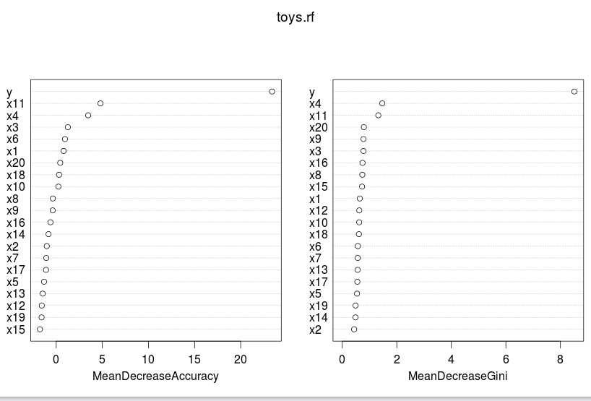

RCODE

##### DATASET FOR NULL MODEL

n_mod<-as.data.frame(matrix(0, ncol = 10, nrow = 50))
n_mod1<- as.matrix(n_mod)
y<-ifelse(runif(50,0,1)<0.5,1,-1)

########---Variable importance of the NULL MODEL------############
############--------------using Random Forest -------##############

library(randomForest)

####---Applying Random Forest on the DATASET----####
n_mod.rf <- randomForest(n_mod1,y =factor(y),importance=TRUE, proximity=TRUE)
print(n_mod.rf)

###-----Calculating Variable importance ------######
VI=importance(n_mod.rf)
order(VI,decreasing = TRUE)
varImpPlot(n_mod.rf)

OUTPUT OF NULLMODEL WITH COMPARISION OF RANKINGS OBTAINED FROM DIFFERENT MODELS:--

1) print(n_mod.rf)

Call:
randomForest(x = n_mod1, y = factor(y), importance = TRUE, proximity = TRUE)
Type of random forest: classification
Number of trees: 500
No. of variables tried at each split: 3

OOB estimate of error rate: 46%
Confusion matrix:
-1 1 class.error
-1 3 15 0.8333333
1 8 24 0.2500000

2) VI=importance(n_mod.rf)
-1 1 MeanDecreaseAccuracy MeanDecreaseGini
V1 -0.8128357 3.6297850 2.7765163 2.128285
V2 0.4324934 -1.7038617 -0.8595474 2.181267
V3 -1.8378860 -0.8772015 -1.6403854 2.186227
V4 -0.6224067 -1.9656249 -1.7545533 1.778680
V5 6.1782843 3.0596107 5.9935276 3.362129
V6 -1.1872775 -1.7635244 -2.1744763 1.767438
V7 3.6919746 3.5279292 5.2577079 3.076840
V8 -2.3304685 -2.2225082 -2.7903563 1.823804
V9 3.7688494 2.1669867 3.9019474 2.685465
V10 -2.3850394 -3.3368312 -3.6691460 1.567545

3)order(VI,decreasing = TRUE)
[1] 5 25 27 29 9 7 11 17 35 37 15 21 39 33 32 19 31 38 34 36 40 2 4 1 22 13 6 23 12 24 16 3 14 26 18 8 10 28 20 30

4) varImpPlot(n_mod.rf)

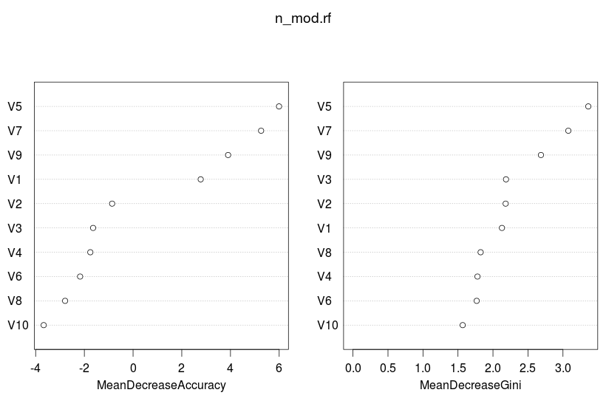

RCODE

##### CORRELATION MODEL DATASET

c_mod<-as.data.frame(matrix(0, ncol = 5, nrow = 50))

y<-ifelse(runif(50,0,1)<0.5,1,-1)

t1_mod <- mvrnorm(50, mu = c(0,0), Sigma = matrix(c(1,0.90,0.90,1), ncol = 2),empirical = TRUE)
View(t1_mod)

t2_mod<-as.data.frame(matrix(0, ncol = 3, nrow = 50))
for (j in 1:3){
t2_mod[,j]<-rnorm(50,0,1)
}
View(t2_mod)
c_mod<-cbind(t1_mod,t2_mod)

########---Variable importance of the CORRELATION MODEL------############
############--------------using Random Forest -------##############

library(randomForest)

####---Applying Random Forest on the DATASET----####

c_mod.rf <- randomForest(c_mod,y =factor(y),importance=TRUE, proximity=TRUE)
print(c_mod.rf)

###-----Calculating Variable importance ------######
VI=importance(c_mod.rf)
order(VI,decreasing = TRUE)
varImpPlot(c_mod.rf)

OUTPUT OF CORRELATION MODEL WITH COMPARISION OF RANKINGS OBTAINED FROM DIFFERENT MODELS:--

1)print(c_mod.rf)

Call:
randomForest(x = c_mod, y = factor(y), importance = TRUE, proximity = TRUE)
Type of random forest: classification
Number of trees: 500
No. of variables tried at each split: 2

OOB estimate of error rate: 52%
Confusion matrix:
-1 1 class.error
-1 11 15 0.5769231
1 11 13 0.4583333

2) VI=importance(c_mod.rf)
-1 1 MeanDecreaseAccuracy MeanDecreaseGini
1 -0.23876136 -0.6599990 -0.7076368 5.265048
2 -3.14612857 -3.8313207 -5.0395974 3.758488
V1 1.68258226 0.6381981 1.5177377 6.309906
V2 -5.47498927 -3.1965780 -5.7280356 4.061807
V3 0.08255632 -0.4431248 -0.1464334 5.111711

3)order(VI,decreasing = TRUE)

[1] 18 16 20 19 17 3 13 8 5 15 1 10 6 11 2 9 7 12 4 14

4) varImpPlot(c_mod.rf)
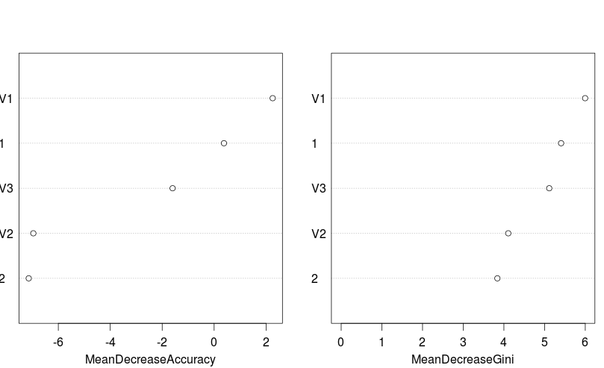

CONCLUSION

The Rankings obtained from the Random Forest Model are more efficient and Stable,When Results of Random Forest is been compared with other models,it gives more efficient results and this gives the proof of being good models than others.

